

Jack Brown’s Beer and Burger Joint

Team 2

Alexis Strickland, Dominant Elting, Khadeem Dublin, Ryan McCrary

Sprint Review and Retrospective 2

February 24th, 2022

**Table of Contents**

Section 1 Executive Summary…………………………………………………………………………………………………….3

Company Background & Current Environment…………………………………………………………………………..4

Problem Analysis……………………………………………………………………………………………………………………….5

Proposed System Objectives and Constraints…………………………………………………………………………….6

Expected Benefits………………………………………………………………………………………………………………………7

Context Diagram………………………………………………………………………………………………………………………..8

Section 2 Executive Summary…………………………………………………………………………………………………….9

Use Case Diagram…………………………………………………………………………………………………………………….10

Preliminary Supplement Specifications…………………………………………………………………………………….11

Section 2 New Documentation…………………………………………………………………………………………………12

**Section 1 Executive Summary**

Sprint one will break down the Company Background and Current Environment, Problem Analysis (BPA) Proposed System Objectives and Constraints, Expected Benefits, and the Use Case and Context Diagram.

For the company background and current environment, we discuss Jack Brown’s Beer and Burger Joint located in Greenville, NC. All locations are owned by Aaron Ludwig and Mike Sabin, while the Greenville location is managed and operated by Adam Lorjust. The local location currently utilizes a hand-written manual inventory system. Due to the increasing demand and growth of the college town, the implementation of a business process automation system would provide immense value. To fill this need, we will be creating an HTML-based site, for both the employees and managers. Our goal is to provide a reliable and efficient system before the semester ends that will save time and bring value to Jack Brown’s.

**Company Background & Current Environment**

Jack Brown’s Beer & Burger Joint, created by Aaron Ludwig and Mike Sabin, is a bar that happens to sell a really fantastic burger. Throughout the last fourteen years Jack Brown’s has implemented fifteen locations ranging from Virginia (5), Tennessee (4), Alabama (2), North Carolina (2), Ohio (1), and South Carolina (1). We will be focusing on the Greenville, NC location, managed by Adam Lorjust. Of all of Jack Brown’s locations, Greenville, NC is one of the smallest towns they’re located in. In previous years, the current system has been able to withstand the small inventory and traffic. With the college town and business growing exponentially, we plan to fulfil the need to create an up-to-date automated system to increase efficiency.

The way Jack Brown’s operates their business is a manual process. Since this is a small restaurant, the number of orders at once is currently bearable for the waitresses to write down orders on paper. The cooks are in the same visual area of the restaurant, so an order will be immediately transported from the table to the cook in a timely fashion without being digital. Although Jack Brown’s does have a digital point-of-sale system to take both card and cash. Their website is also fully operational with an updated menu of both their daily items and specialty burgers available. Their drink menu is outsourced through Untapped, which is a system that most breweries use to allow customers to keep up with a location’s current beers on tap.

**Problem Analysis**

When our team visited Jack Brown’s, we discovered that their current inventory system was being operated via paper and word of mouth. Fortunately, the manager walked us through their business processes and explained some problems he needed us to fix. We quickly concurred that BPA was needed for this business process to help efficiency, time management, and customer service. Furthermore, we realized that we could use BPI in order to create an inventory alert system, notifying the manager if a certain item was low.

**Proposed System Objectives & Constraints**

The system we are proposing will be an HTML-based website that gives access to both the manager and the employees. The main objective for this system is to automate how the business manages their inventory. Specifically for the manager, he will have full capabilities of modifying the inventory digitally. After creating inventory lists within the system, the manager can then set levels for each inventory item to send alerts when the item is below that certain level. The system will contact an email server to send those alerts in reaction to the inventory numbers. For employees, they will have the ability of quickly recording when they are removing an item from inventory. They will not have the full capabilities the manager would, which would lead to having two separate logins for the manager and employees.

Some of our biggest constraints pertain to the employees using the system. First, the system would need an area to operate with ease of access for the employees. An idea for this would be to mount a tablet outside of the main inventory storage area that shows the system operating. This would be showing a specific item from the inventory and buttons indicating a decrease or increase of that item. Purchasing a tablet for that use would be a financial constraint on the company. The manager already possesses his own computer to operate the system, but no technology is currently in use for the employees. Second, this restaurant has rush hours that can limit the time employees have available to record inventory. Having the simple design of an item name with only clicking a decreasing button should ease this constraint.

**Expected Benefits**

Upon discovering their current system, we have expected our automated system to improve efficiency, customer service, and setting trends for the company. As of now, keeping track of their inventory is written on paper and is counted only manually by the employees.

The automated system will allow the manager and employees to have their own logins to either an app or website, that will keep track of the inventory at an easier and efficient rate. With the separate logins the manager will have a wider range of operations, while the employee's functionality will depend on the manager.

The manager will be given a working system with an easy-to-access database of all their inventory to create shipping orders in a timely manner. Whether this system is accepted or not, we expect new trends and for Jack Brown’s to reach out and install its own automated system for better quality.

Finally, our up-to-date inventory will show the manager which items the customers prefer each week to have a better understanding of what to order exactly. For a restaurant that changes menu items every week this will create patterns in customer activity and overall, have a better customer experience.

**Context Diagram**

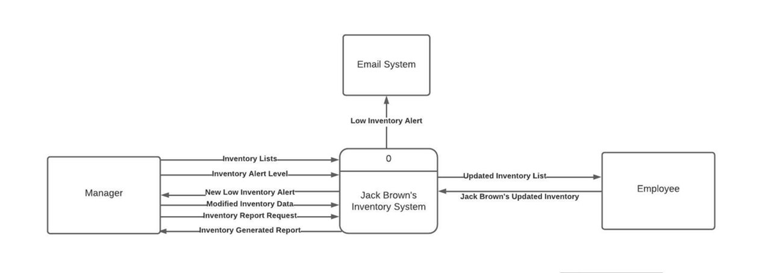

**Section 2 Executive Summary**

Sprint 2 includes an updated version of the use case diagram, preliminary supplement specifications the system will require, and new documentation.

For the updated case diagram, we simply applied the constructive criticism received and made corrections such as connecting actors to processes and removing our “report inventory levels” process. This sprint also included the creation of our systems preliminary supplement specifications, clarifying operational, performance, security, and cultural/political requirements. Our new documentation contains feedback and information we gathered when meeting with our product owner to gain a better understanding of the requirements needed.

**Use Case Diagram**

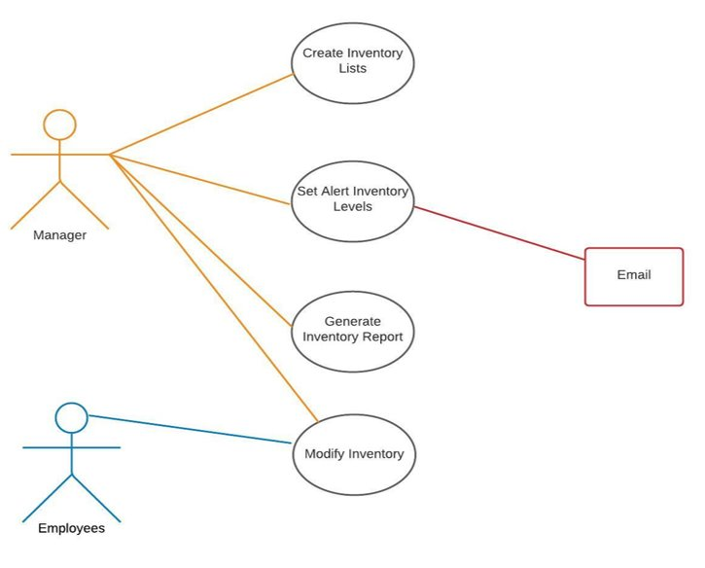

**Preliminary Supplement Specifications**

|  |  |
| --- | --- |
| Non-Functional Requirements | |
| Operational | * The system must run preferably on the manager’s Android phone and iPads * System must be able to run on standard web browsers * Data must be held/stored quarterly |
| Performance | * The system should be capable of handling at least 20 users at the same time * Maintenance of the system should not be completed on weekends, any day from 12:30pm-3:30pm, and any day from 6pm-8pm * The system should update the inventory database immediately after recording items * The system should be able to respond within 3 seconds * The system should be able to store at least 5GB of data |
| Security | * The system would have two logins, one for the manager and one for the employee * Managers would have access to all reports in the system * System should record who inputs data and when they have recorded the information * Managers give employees limited access |
| Cultural and Political | * Personal information is protected in compliance with the Data Protection Act * Manager has full authorization over employee interfaces * The system should not display any offensive icons or messages |

**New Documentation**

During this sprint, our team met with the manager of Jack Brown’s to ask questions clarifying the nonfunctional requirements. While understanding the operating system requirements, Adam supported our idea of putting a tablet up in the restaurant near the inventory storage area. This was a financial constraint mentioned in our last sprint that is now a feasible option. With the tablet, our original plan was to have it mainly be used by the employees. Adam has decided not to allow the employees to have that access but keep it as a job for management. This changes some of the use cases about how an employee would use the tablet. Although, we decided to keep this access available for lower management, such as assistant managers or anyone that would be next to Adam. Adam would have the choice of allowing the lower management to login, but the system will provide it in case he needs to rely on someone else. Lastly, Adam informed us that he would additionally like access to this system on his mobile device, which runs on an Android operating system. Our team will need to be sure that the system successfully runs the same way on a desktop browser, a tablet, and a mobile device.